DOCUMENTATION ON WN 2.0 API PONT

API access workflow
First generate the authorization token
- Token
  - https://warrantnowdemos.com/WarrantNowMobServiceAndroid/token
then use that token to access below API
- GetWarrantList
  - https://warrantnowdemos.com/WarrantNowMobServiceAndroid//API/Warrant/GetWarrantList
- GetWarrant
  - https://warrantnowdemos.com/WarrantNowMobServiceAndroid//API/Warrant/GetWarrant
- GetArchivedWarrantList
  - https://warrantnowdemos.com/WarrantNowMobServiceAndroid//API/Warrant/ GetArchivedWarrantList
- PreviewWarrantFileURL
  - https://warrantnowdemos.com/WarrantNowMobServiceAndroid//API/Warrant/ PreviewWarrantFileURL

For Accessing and testing the API we are using POSTMAN

Steps to generate authorization token.

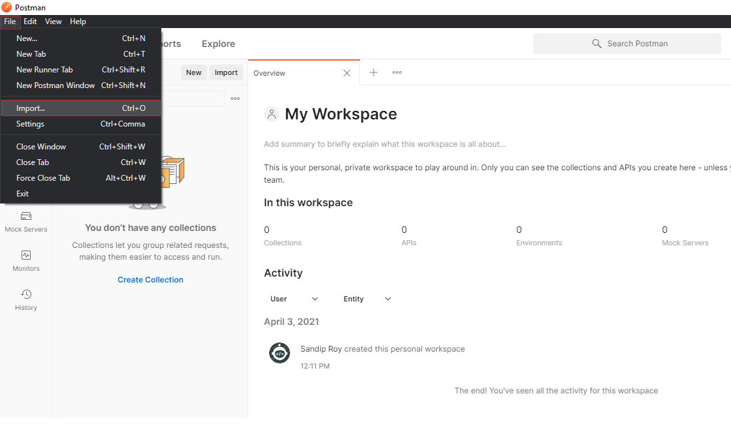
- In Postman click on File then click on Import

- Select Raw text from Import window and paste the below code.

curl --location --request POST 'https://www.warrantnowdemos.com/warrantnowmobserviceandroid/token' \
--header 'SecurityKey: 1234' \
--header 'Content-Type: application/x-www-form-urlencoded' \
--data-urlencode 'username=wnd@uat.com' \
--data-urlencode 'password=1234' \
--data-urlencode 'grant_type=password'

Then click on Continue and then click on Import
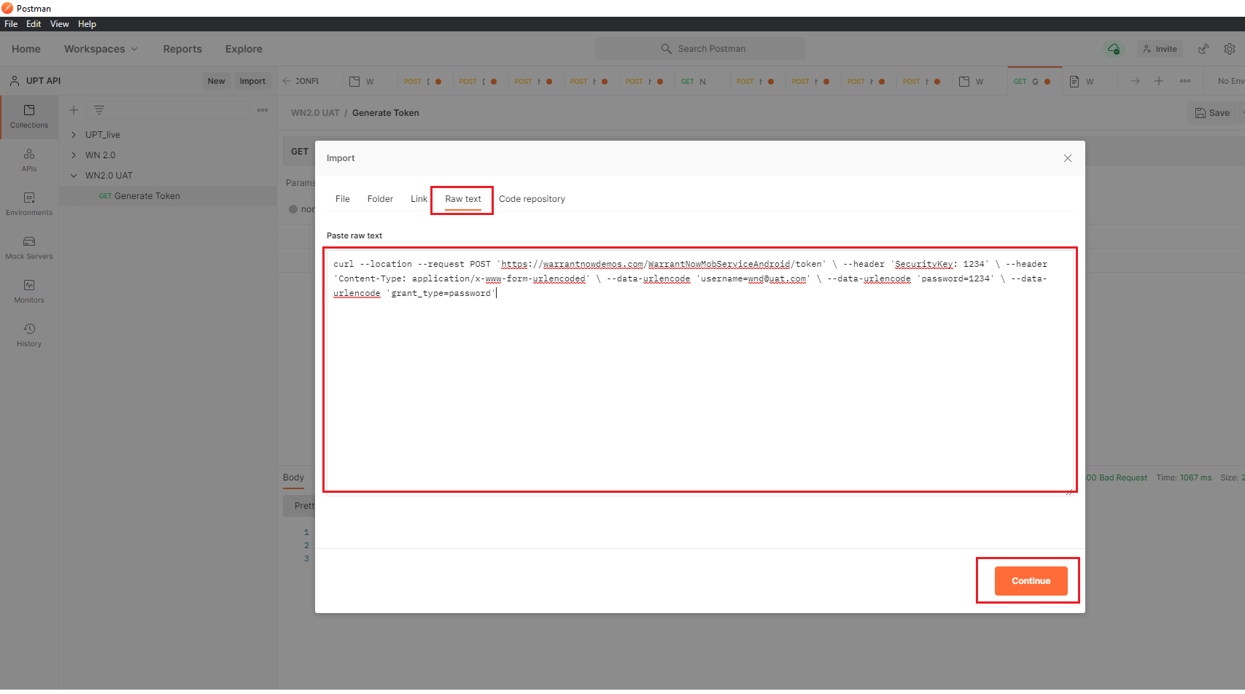
NB: Change value of username, security key, password as per requirement
- Click on Send and an access_token will be generated.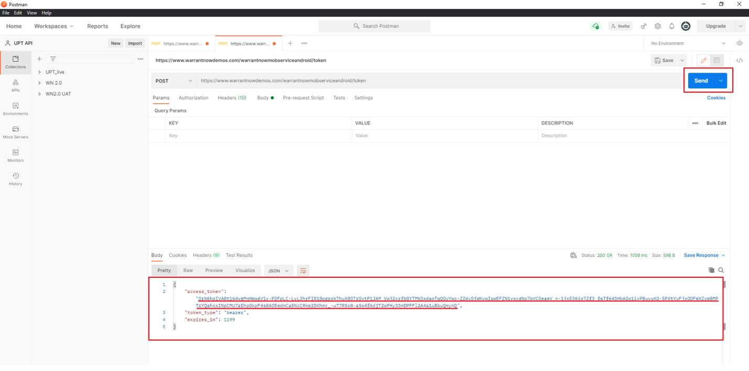
Copy the token for future use.

Stapes to Access the Warrant List

- Import the below code in Postman.
(File-> Import-> Raw text -> paste the code -> Continue ->Import)
curl --location --request POST
'https://www.warrantnowdemos.com/WarrantNowMobServiceAndroid//API/Warrant/GetWarrantList' \
--header 'Content-Type: application/json' \
--header 'Authorization: Bearer paste your generated access token here' \
--data-raw '{"warrantList":{"ID":0,"WarrantNumber":null,"ClientId":##,"TemplateId":0,"TemplateName":null,"WarrantName":null,"CategoryName":null,"ClientName":null,"CurrentWarrantStatusID":0,"CurrentWarrantStausName":null,"WarrantActionList":null,"UserID":##,"PreviousStausID":null,"PreviousStausName":null,"DetectiveID":0,"DetectiveName":null,"JudgeName":null,"ReviewerName":null,"SortedText":"UpdatedOn","SortedOrder":0,"IsVideoCall":null,"UserTypeId":#,"SuspectName":null,"InputWarrantNumber":null},"Paging":{"Skip":0,"Take":10,"RecordCount":0},"CallerInfo":{"AppId":null,"AppVersion":null,"CorelationId":"00000000-0000-0000-0000-000000000000"}}'
NB: Change "ClientId":##, "UserID":##, "UserTypeId":# , according to user and client.

Below items are available as UserTypeId
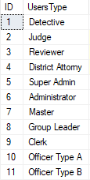
- After importing the code click on send and will show the warrant list
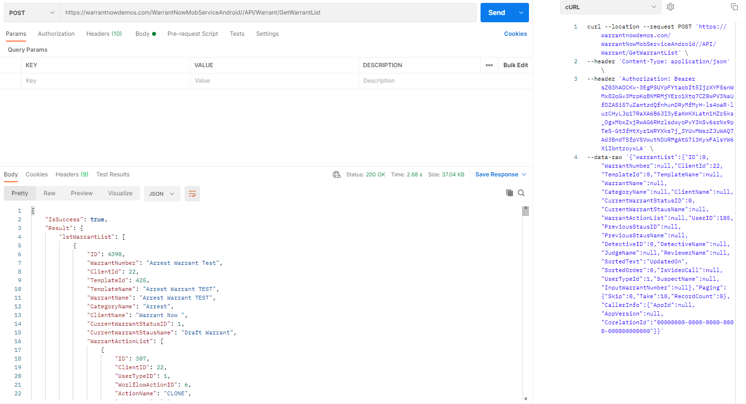

Steps to Access the Warrant Data

- Import the below code in the Postman.
(File-> Import-> Raw text -> paste the code -> Continue ->Import)
curl --location --request POST 'https://www.warrantnowdemos.com/WarrantNowMobServiceAndroid//API/warrant/GetWarrant' \
--header 'Content-Type: application/json' \
--header 'Authorization: Bearer paste your generated access token here ' \
--data-raw '{"Warrant":{"ID":##,"WarrantNumber":null,"ClientID":null,"UserID":null,"TemplateID":null,"WorkflowID":null,"WarrantDetailsString":null,"CreatedBy":null,"CreatedOn":null,"UpdatedBy":null,"UpdatedOn":null,"WarrantDetails":null,"IsActive":null,"WordFilePath":null,"WordFileName":null,"PDFFilePath":null,"PDFFileName":null,"CurrentWarrantStatusID":0,"CurrentWarrantStausName":null,"WarrantActionList":null,"UIWarrantActionID":0,"UIWarrantActionCode":null,"CurrentWarrantUserType":0,"CurrentWarrantUserTypeName":null,"CurrentWarrantUserID":0,"SubmitToUserID":null,"ActionComment":null,"EmailFrom":null,"EmailTo":null,"EmailText":null,"UserListRequest":false,"UserList":null,"IsVideoCall":null,"BondTemplateHeaderID":null,"BondDetailsString":null,"BondDetails":null,"BondScreenDetails":null,"IsBondAttached":null,"WarrantTypeID":null,"SuspectName":null,"InputWarrantNumber":null,"EmailList":null,"AttachInitial":false}}'
NB: Change "ID":## , according to requirement.
- After Import click on Send Button to get warrant data
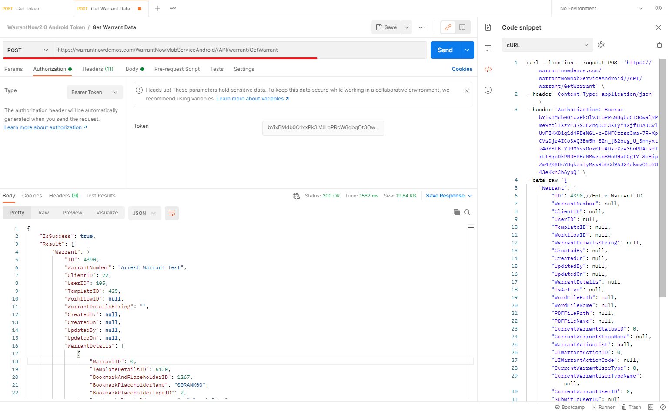

Steps to Access the Archived Warrant List

- Import the below code in Postman.
(File-> Import-> Raw text -> paste the code -> Continue ->Import)
curl --location --request POST
curl --location --request POST 'https://www.warrantnowdemos.com/WarrantNowMobServiceAndroid//API/warrant/GetArchivedWarrantList' \
--header 'Content-Type: application/json' \
--header 'Authorization: Bearer paste your generated access token here ' \
--data-raw '{"Archivedwarrants":{"Archived":0,"IsArchived":false,"Archivedate":null,"ID":0,"WarrantNumber":null,"ClientId":##,"TemplateId":0,"TemplateName":null,"WarrantName":null,"CategoryName":null,"ClientName":null,"CurrentWarrantStatusID":0,"CurrentWarrantStausName":0,"WarrantActionList":null,"UserID":##,"UpdatedOn":null,"PreviousStausID":null,"PreviousStausName":false,"DetectiveID":0,"DetectiveName":null,"JudgeName":null,"ReviewerName":null,"SortedText":"UpdatedOn","SortedOrder":0,"IsVideoCall":null,"UserTypeId":#,"SuspectName":null,"InputWarrantNumber":null},"Paging":{"Skip":0,"Take":10,"RecordCount":0},"CallerInfo":null}'
NB: Change "ClientId":##, "UserID":## , "UserTypeId":# , according to user and client .
Below items are available as UserTypeId

- After importing the code click on send and will show the Archived warrant list
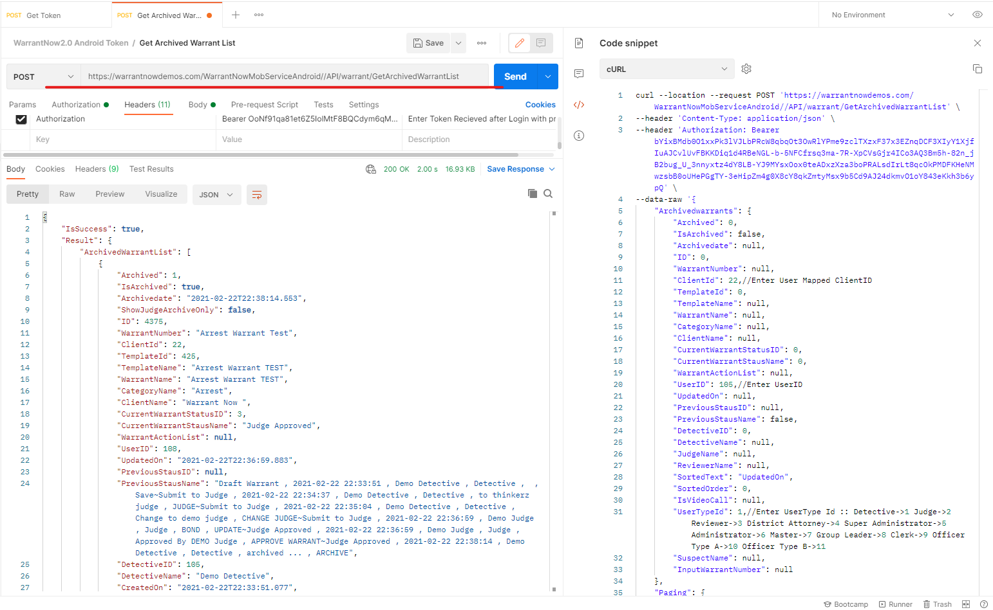

Steps to Access the Preview Warrant API

- Import the below code in Postman.
(File-> Import-> Raw text -> paste the code -> Continue ->Import)
curl --location --request GET 'https://warrantnowdemos.com/WarrantNowMobServiceAndroid/API/Warrant/PreviewWarrantFileURL/####/4/##' \
--header 'Authorization: Bearer paste your generated access token here'.
Note: {####(warranted)}/4/{##(userId)} Change As per required warrant id and user id
- After importing the code click on send and will get the warrant preview pdf link.
